**AIRLINE MANAGEMENT SYSTEM**

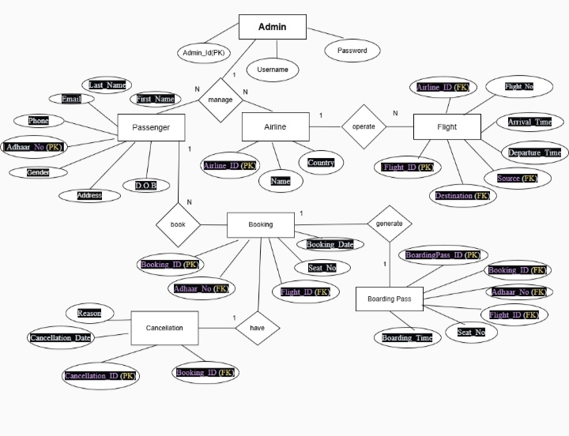

**Relationships**

* Admin manages all operations in the system.
* Admin can add and manage Customers (1:M).
* Admin can add and manage Flights (1:M).
* Admin can create Bookings for Customers (1:M).
* Booking can generate one Boarding Pass (1:1).
* Booking can have one Journey (1:1).
* Journey can have one Cancellation (1:1).

**Entities and Attributes**

1. **Admin**
   * Username
   * Password
2. **Customer**
   * First_Name
   * Last_Name
   * Nationality
   * Aadhar Number (Primary Key)
   * Address
   * Gender
   * Phone
3. **Flight**
   * Flight_code (Primary Key)
   * Flight_name
   * Flight_source
   * Flight_Destination
   * Flight_Amount
4. **Booking**
   * Aadhar Number (Primary Key)
   * Source
   * Destination
   * Date
   * Seat_NO
   * Class
   * Payment
5. **Journey**
   * PNR_Number (Primary Key)
   * Ticket_ID
6. **Cancellation**
   * PNR_Number (Primary Key)
   * Cancellation_ID
7. **Boarding Pass**
   * PNR_Number (Primary Key)